
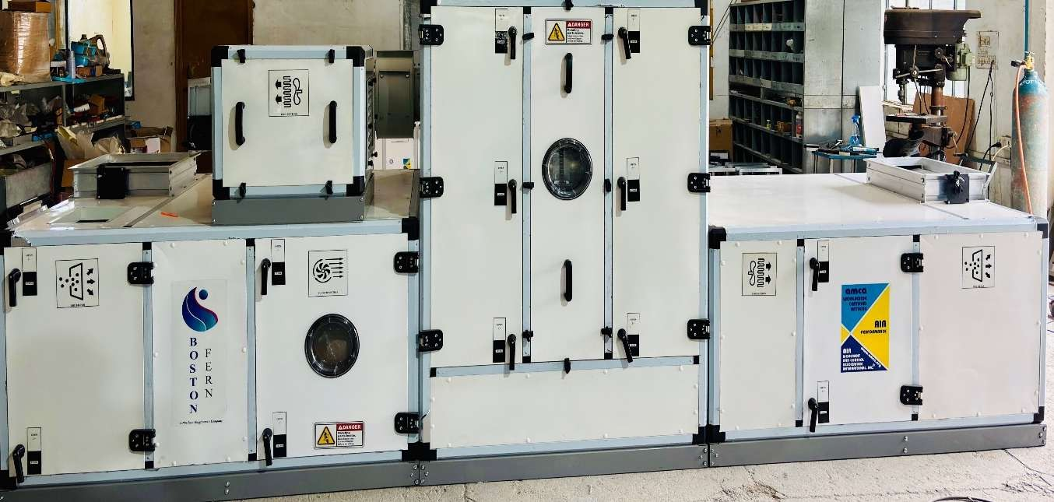

GMP VISION
Floor No. Ground floor,
Building No/Flat No.-01,
Road/street: - Amb Daultpur Road,
City/Town/Village: - Bhanjal, District: -Una
Himachal Pradesh (INDIA) 177213
E-mail: gmpvision3@gmail.com | M: 9317343117












Indoor and OUT Door Units Repair maintenance & procurement and designing VRV Units

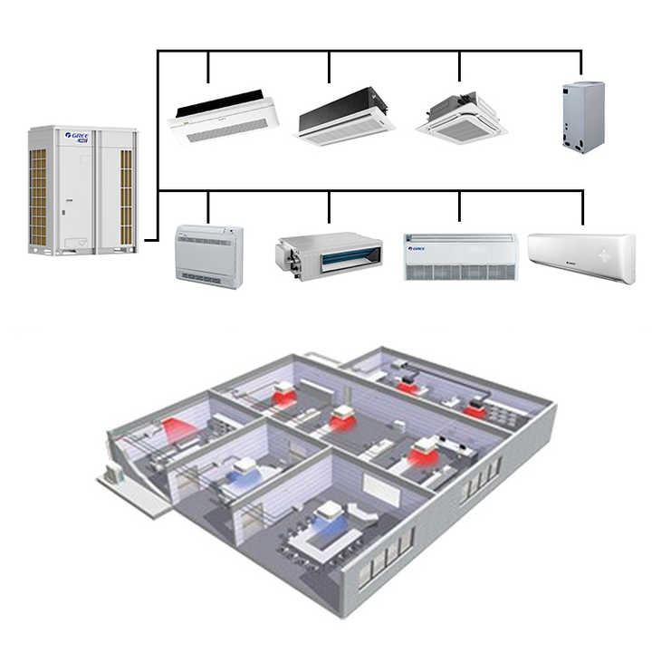



About Us

GMP VISION is one of the leading company in Turnkey projects, Cleanroom Modular panels, Cleanroom equipment's, HVAC equipment's, dehumidifier, Air distribution products etc., along with design development and Installation. We at GMP VISION under take Turnkey projects from concept to completion with in the customer budget. Our dedicated and trained team providing them best custom -built solution. With this experience expertise, we are manufacturing a wide range of clean room and
Hot water & Chilled water and Steam Coils High Efficiency Coils Procurement and Installation work

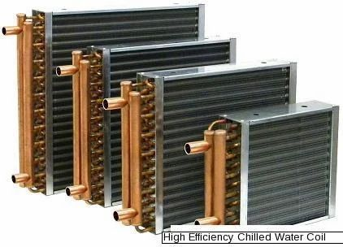

All Type SS and MS pipe line and structure work

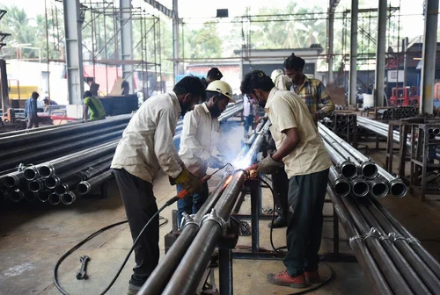

Non-Thermal break Al profile


COMPLETED PROJECT LIST
COMPLETED PROJECTS | SCOPE | LOCATION | STATUS
M/s Zeon Healthcare Ltd | HVAC Turnkey with EMS | Paonta Sahib, HP | Completed
M/s. Penam Lifesciences | HVAC Turnkey | Yamuna Nagar | Completed
M/s. Verve Human Care | HVAC Turnkey | Dehradun | Completed
M/s. SKS Metals | HVAC Turnkey & Dehumidifier | Kalamb | Completed
M/s. Skins Pharma | HVANCoTnu-rTnhkeerymal break Al profile | Baddi | Completed
M/s. Relax Pharma | SMART AHU SITC | Ponta Sahib | Completed
M/s. Ritz Lifestyle | HVAC Turkey | Dehradun | Completed
M/s. Daffoils Laboratories | AHU Supplied | Dehradun | Completed
M/s. Windlass Biotech Ltd Plant-4 | AHU & Dehumidifier | Dehradun | Completed
M./s Uni Medico Labs | AHU & Ducting | Dehradun | Completed
And Many More . . . . . . . .

Non-Thermal break Al profile
COMPLETED PROJECT LIST
  COMPLETED PROJECTS | SCOPE OF WORK | LOCATION | STATUS
M/s. Wallace Pharma Unit-1 | Ducting & AHU | Kalamb | Completed
M/s. Wallace Pharma Unit-2 | AHU & CHW Coils | Jammu | Completed
M/s. Sarika Biotec | AHU & Ducting | Kalamb - Nariangarh | Completed
M/s. Hindustan Antibiotics Ltd | NoHnV-ATChe&rmCRalPbTruerankkAeyl profi | lePune | Completed
M/s. Osppa Enterprise | Dehumidifier | Ahmedabad | Completed
M/s. Apy Pharma | AHU Supply | Guwahati | Completed
M/s. Pellcabs India Pvt Ltd | HVAC | Kalamb | Completed
And Many More . . . . . . . .

Non-Thermal break Al profile

Executive Team

Mr. Praveen Kumar
CEO
Experience: 15 Years

Mr. Sachin Thakur
Projects Heads
Experience: 21Years

Mr. Promise
Planning Leads
Experience: 05 Years



Mission
Our mission is to design & manufacturer high-quality air handling systems, dehumidifier & Modular CRP that exceed industry standards in Performance, Reliability, Sustainability & Energy Efficiency




Vision
To be a leading provider of innovative, energy-efficient air handling unit & dehumidifier worldwide.



Expertise

With over a decade of industry experience, we have built a reputation for engineering excellence and unparalleled service quality. From conceptual designing to installation, validation, and technical support, our team of highly skilled engineers ensures precision and excellence at every stage.

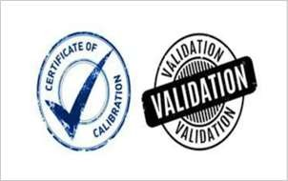
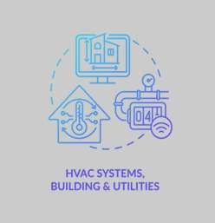


Our Products and Services

VALIDATION & CSV VALIDATION
HVAC & AHU TURNKEY PROJECTS
Repair & SPARES

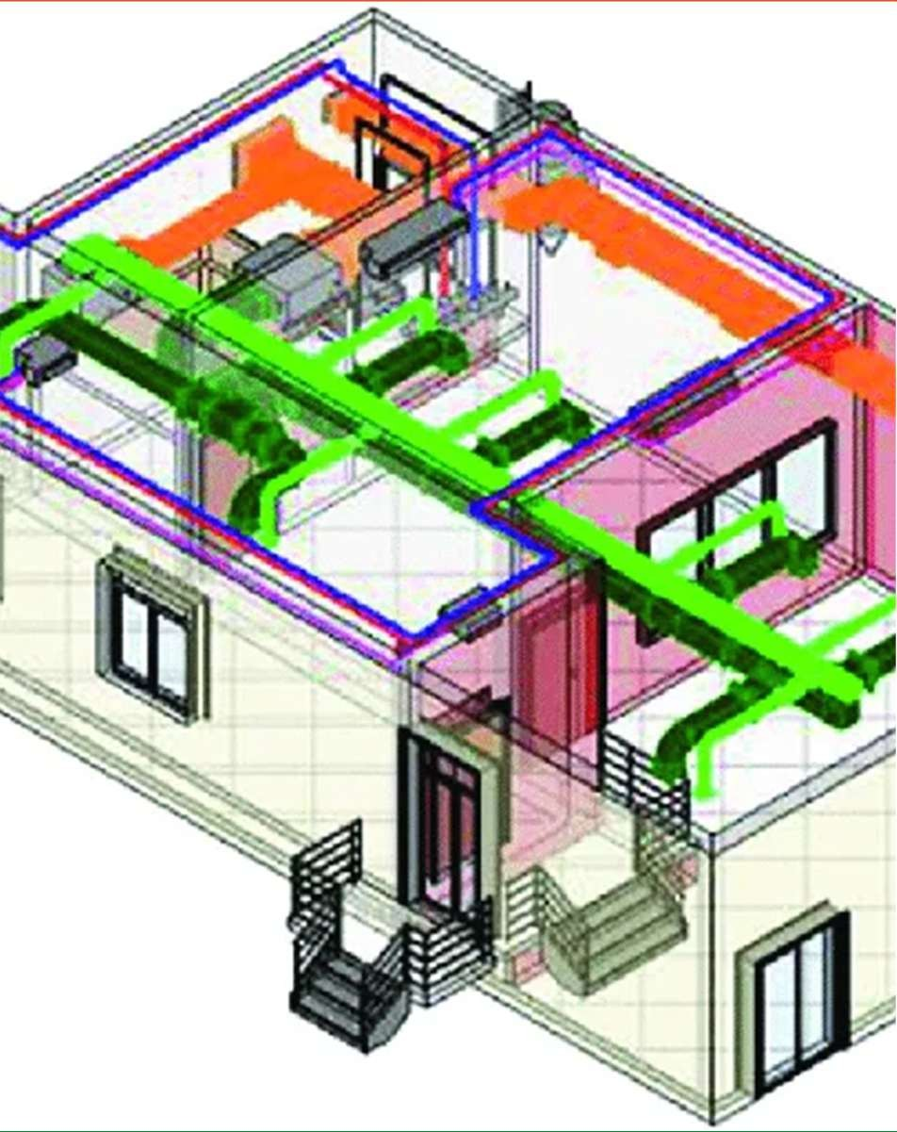

What We Do?
- HVAC TURNKEY PROJECTS
- AIR HANDLING UNIT (AHU)
- DEHUMIDIFIER
- CONCEPTUAL DESIGNING
- VALIDATION
- TEMPERATURE MAPPING

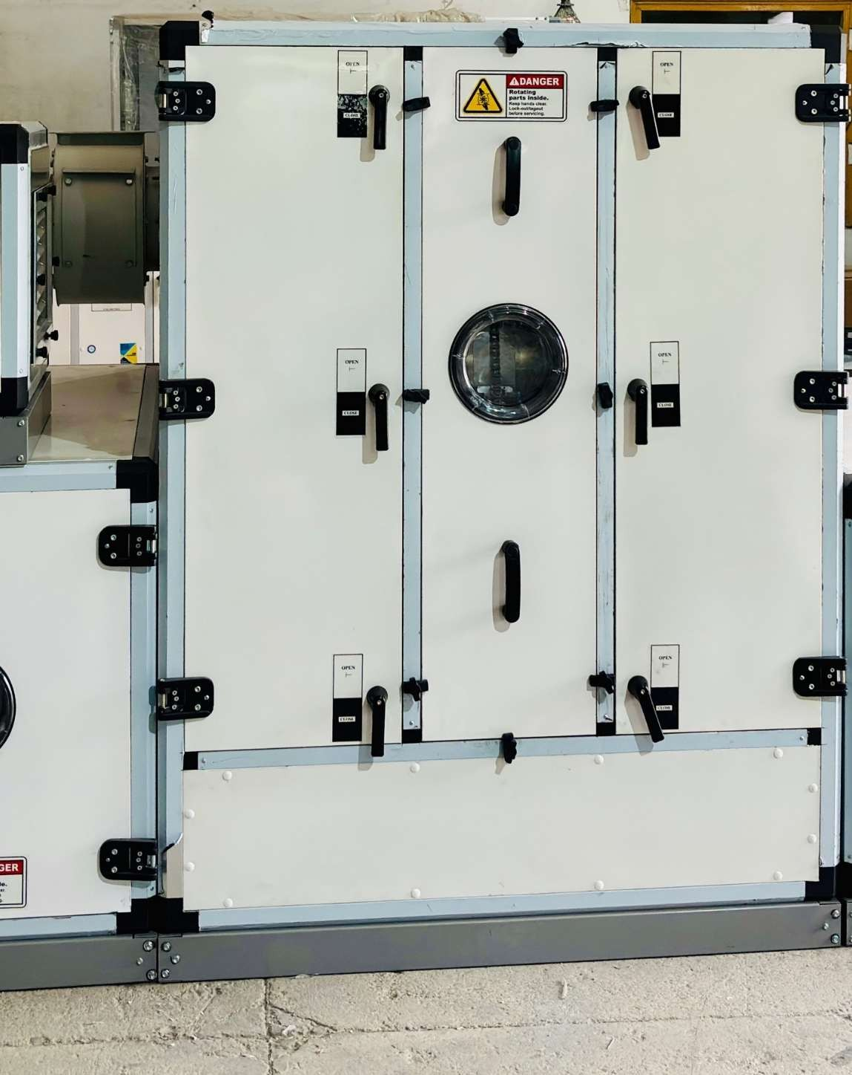

Our products & Service’s
- AIR HANDLING UNIT (AHU)
- DEHUMIDIFIER
- FAN COIL UNIT (FCU)
- AIR WASHERS
- HEAT RECOVERY UNITS
- COOLING COILS
- HEATING COILS

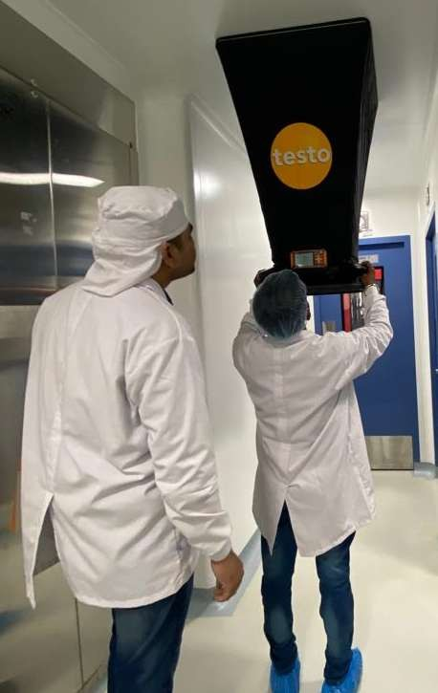
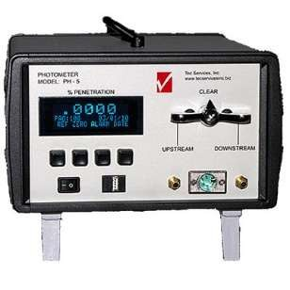
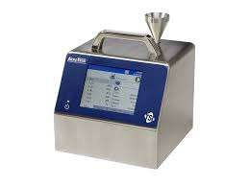
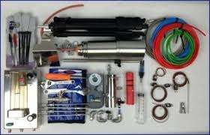
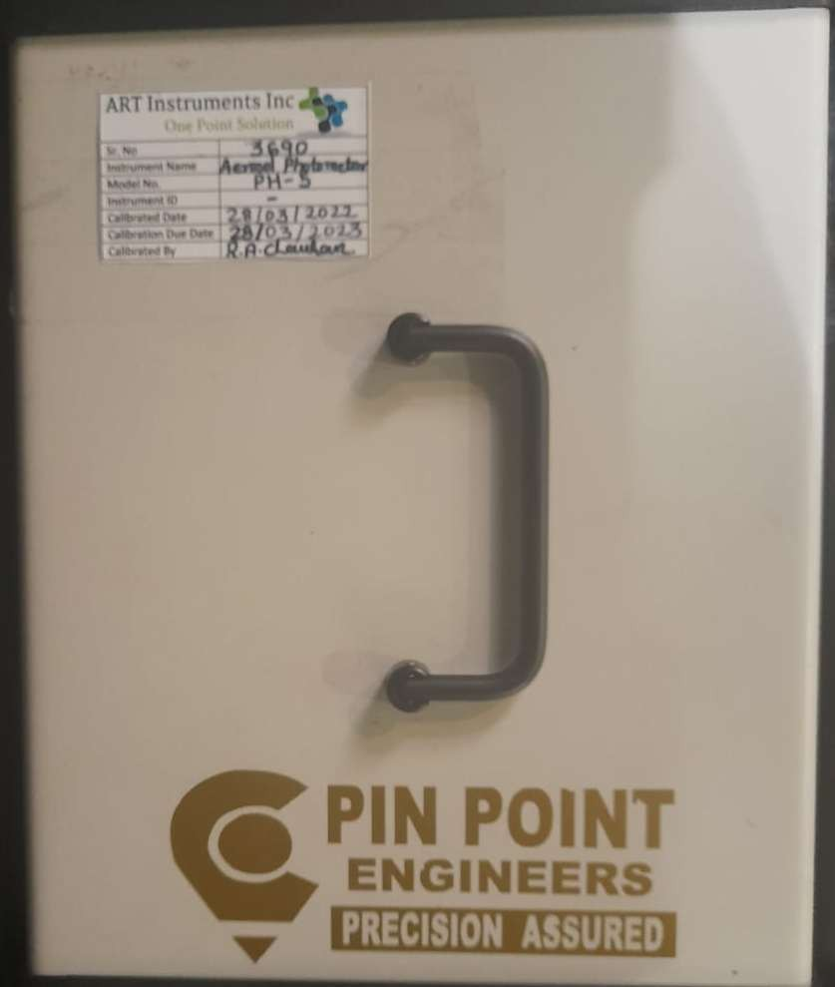

OUR SERVICES

- PURE STEAM VALIDATION
- COMPRESSES AIR & NITROGEN AIR TEST
- AHU VALIDATION
- CONCEPTUAL DESIGNING
- AHU & DUCTING DESIGN (AS PER ISHRAE / ASHRAE)
- THERMAL VALIDATION | AREA MAPPING | EQUIPMENT MAPPING

Non-Thermal break Al profile
Non-Thermal break Al profile



CUSTOMER SUPPORT POLICY !

- cGMP COMPLIANCE
- EUROVENT COMPLIANCE
- 24 X 7 SUPPORT
- CUSTOMER DELIGHT
- TIMELINES
- AFFORDABLE PRICES

Key Benefits of Partnering with Pin Point Engineers
- Experienced team having pharmaceutical industrial knowledge of 10+ Years.
- ISPE Certified Member.
- Assuring the affordable cost with others.
Non-Thermal break Al profile

- 24X7 Customer Support.
Non-Thermal break Al profile

- Well Documentation (Follows GDP)
- ISHRAE Certified Engineers



